How to Fight Anti-Semitism?

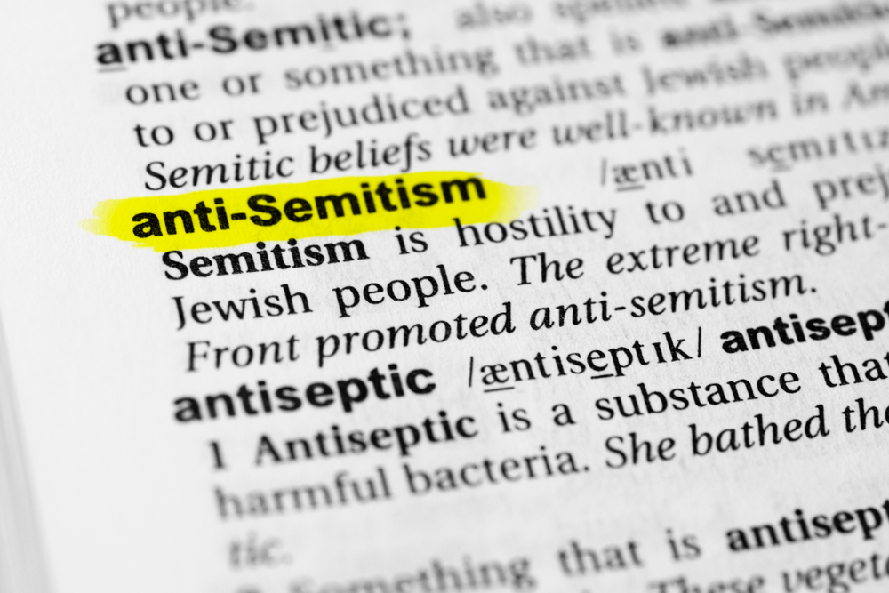
#1
French Rabbi: Wear Baseball Caps, Not Skullcaps, in Public; Haaretz, Nov. 19, 2003
The Chief Rabbi of France, Rabbi Joseph Sitruk, called on that country's Jewish community to wear baseball caps instead of skull caps while not in their homes, in order "to prevent being attacked in the street."

Question: Do you think the Jews should not display their Judaism, e.g. star of David, outwardly?

#2
The Right Response to the Anti-Semitic Attack in Monsey, N.Y., New York Times, By Nita Lowey and David Harris, Dec. 30, 2019
Why, when American Jews have felt unmatched levels of inclusion and equality, and when, unlike in previous generations, Jews can be found in every sphere of American society, is anti-Semitism making a comeback?

Questions:
- Why do you think there has been a rise of anti-Semitism in recent times?
- Is there anything we can do to prevent it?
- Are there any behaviors that increase anti-Semitism, and which we can/should avoid?
- What's the best way to respond if encountering anti-Semitism?

#3
Jew vs. Jew, The Jewish Press, By Steven Plaut, Feb. 10, 2010
It sounds like a contradiction in terms. An oxymoron. If only it were. Jewish anti-Semitism is a modern disease. The world is experiencing an explosion of it. Among the most malicious and venomous of all bigots, Jewish anti-Semites are at the forefront of just about every smear campaign against Israel and other Jews.

Jewish Self-Hatred: Anti-Semitism and the Hidden Language of the Jews, by Sander Gilman
Self-hating Jew or self-loathing Jew (also Auto-Antisemitism) is a pejorative term used for a Jew who is alleged to hold antisemitic views.

Question: What could be the reason for this phenomenon?

#4
Talmud Megillah 14a
Greater was the removal of the ring [of king Achashverosh] than the 48 prophets and 7 prophetesses who prophesied for Israel, for all of them did not return them to good, yet the removal of the ring returned them to good.

(It was only when Achashverosh took off his ring, letting Haman know that he was free “to destroy, to slay, and to cause to perish, all Jews, both young and old, little children and women, in one day”, that the Jews truly felt they were in danger. As long as it was their own people chastising them, they remained comfortable in their ways, confident that a father would never truly hurt his children. But once an outsider threatened them - and with annihilation, no less - they began to realize that they were in real danger from an enemy who wanted them dead.)

Questions:
- Does this story imply that anti-Semitism can be positive? What do you think about that?
- Have you ever seen anti-Semitism lead to something positive?

#5
The Right Response to the Anti-Semitic Attack in Monsey, N.Y., New York Times, By Nita Lowey and David Harris, Dec. 30, 2019
It is important to remember that anti-Semitism has been called the world’s oldest social disease.

Jewish History Atlas, by historian Martin Gilbert
As my research into Jewish history progressed, I was surprised, depressed, and to some extent overwhelmed by the perpetual and irrational violence which pursued the Jews in every country and to almost every corner of the globe.

Question: What is the root of anti-Semitism?

#6
Confessions of an Atheist, Aldous Huxley
I had motives for not wanting the world to have meaning; consequently, I assumed that it had none and was able without any difficulty to find satisfying reasons for this assumption. For myself, as no doubt for most of my contemporaries, the philosophy of meaninglessness was essentially an instrument of liberation. The liberation we desired was simultaneously liberation from a certain political and economic system and liberation from a certain system of morality. We objected to morality because it interfered with our sexual freedom.

Anti-Semitism and the Holocaust, by Rabbi S. Simmons
Before the Torah was given, people built their lives on a subjective concept of right and wrong. At Sinai the Jewish People were told that there is one G-d for all humanity who makes moral demands on human beings. You can’t just live as you please; there is a higher authority you are accountable to.

Talmud Shabbos 89
The Torah was received at Mount Sinai. The Hebrew pronunciation of "Sinai" is almost identical to the Hebrew word for "hatred" – sinah. Why was the Torah given on a mountain called Sinai? Because the great sinah – the tremendous hatred aimed at the Jew – emanates from Sinai.

Questions:
- What do you think about this?
- If we accept this explanation, what about the secular Jews that do not keep Torah? Why would anyone hate them?

#7
Based on Chasam Sofer, commentary on Torah
This is the pattern of the Jewish nation in all of our exiles. As long as we remember that our home is Israel and that we are guests in the lands in which we stay, we will live in peace. But as soon as we forget it, as soon as we think that we belong, as soon as we become a piece of the fabric of the country – then anti-Semitism appears.

The Spiritual Roots of Anti-Semitism, by Sarah Y. Rigler
Anti-Semitism is the Divine equivalent of the parent of a diabetic child locking the cookie jar. A Jew in 15th century Spain or 20th century Germany or 21st century America may want to blend in with the surrounding society, but anti-Semitism is a sealed door, strong and black as iron, which keeps him out – and separate. Anti-Semitism keeps the Jewish people from dissipating into oblivion.

#8
Question: What’s your takeaway from today’s discussion?

